**What is the difference between cat and more command?**

The ‘cat’ command displays the entire contents of a file or multiple files at once, while the ‘more’ command displays the file contents page by page.

The ‘cat’ command is commonly used to have a quick view of small file contents, while the ‘more’ command allows viewing the contents of a file by one screen at a time.

**What is the difference between rm and rmdir using man?**

the rm command can delete both empty and non-empty directories. By default, when used without any option rm does not remove directories. rmdir will only remove a directory if the directory is empty.

**Create the following hierarchy under your home directory:**

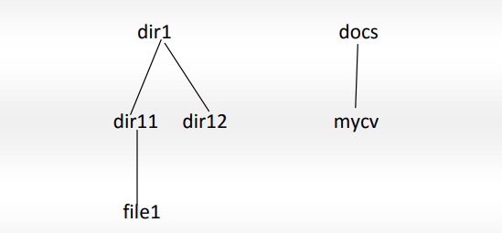

Mkdir -p -v dir1/dir11 dir1/dir12 docs

Touch dir1/dir11/file1.txt docs/mycv.txt 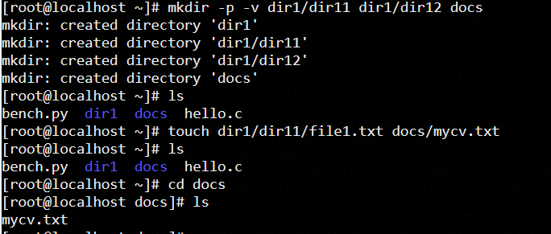

**Remove dir11 in one-step. What did you notice? And how did you overcome that?**

Rm -r dir11 I overcame the problem using -r option

**Then remove dir12 using rmdir –p command. State what happened to the hierarchy**

Rmdir -p dir1/dir12 the whole hierarchy got deleted

**The output of the command pwd was /home/user. Write the absolute and relative path for the file mycv**

Absolute : /home/user/docs/mycv.txt

Relative: docs/mycv.txt

**Copy the /etc/passwd file to your home directory making its name is mypasswd.**

Cp /etc/passwd /home/mypasswd

**You are in /usr/bin, list four ways to go to your home directory**

Cd /home

Cd

Cd ~

Cd ../.../home

**Display the first 4 lines of /etc/passwd**

Head -4 /etc/passwd

**Display the last 7 lines of /etc/passwd**

Tail -7 /etc/passwd

**Display the man pages of passwd the command and the file sequentially in one command**

Man passwd ; man /etc/passwd

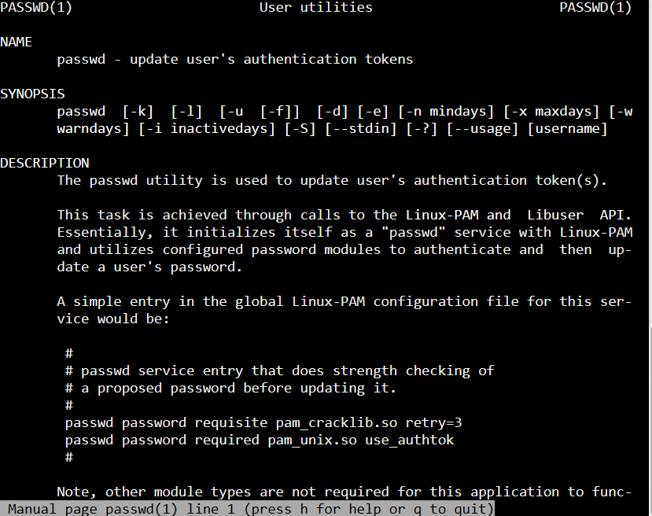

**Display the man page of the passwd file.**

Man /etc/passwd

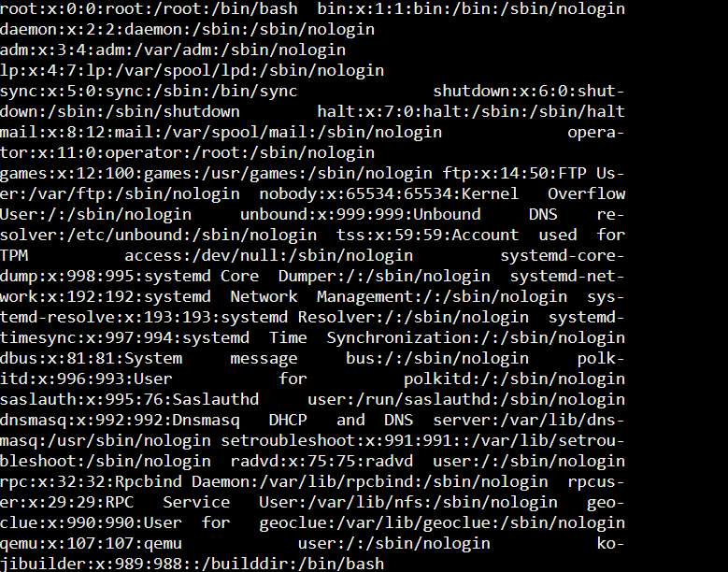

**Display a list of all the commands that contain the keyword passwd in their man page.**

Man -k passwd

